# Cors

It is used to connect front-end and backend

# Select:false

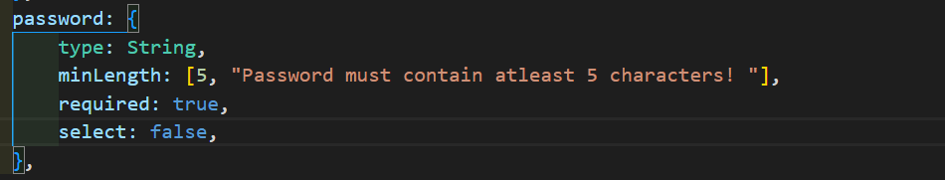

When we will send a get request to a user then other password everything will come in result



When we are retrieving the user then using select(+) we can get the password